Digital Audio Signal Processing Assignment 2 Report

Nathan Berwick – u1453415

Contents

Objectives and Introduction 3

Background and Literature Review 4

dsPIC 4

Tremolo 4

Vibrato and Flanger 5

Chorus 5

Wah 5

Bitcrusher 5

Distortion 5

Design and Implementation 6

Timers 7

TMR1 – Audio Interrupt 7

TMR2 – Look Up Table Read-In 7

TMR3 –Analogue Digital Conversion 7

TMR4 – Button Reading 7

Audio Processing 8

Tremolo 8

Vibrato and Flanger 10

Chorus 10

Bitcrusher 11

Distortion 13

Wah 14

Look Up Tables 15

User Interface 16

Switching 17

Visual Display 17

Fractional Interpolation 18

Program Flow 18

Results, Further Work, Conclusion, and Discussion 19

Glossary of Abbreviations 23

References and Bibliography 24

# Objectives and Introduction

This project aims to create a multi-FX processor, inspired by systems like the Line 6 Helix (Yamaha Guitar Group, 2019), including Tremolo, Vibrato, Chorus, Flanger, Bitcrusher, Distortion, and Wah-Wah.

The report opens discussing effect types, standard digital implementation, and a general DSP system overview. “Design and Analysis” discusses specific dsPIC implementation. “Results, Further Work, Conclusions, and Discussion” outlines implemented effects, assignment results, further work and criticism.

# Background and Literature Review

## dsPIC

A PIC micro system comprises a Central Processing Unit, Clock, Program Memory, Data Memory, and Input and Output Ports (Fenton, 2019a). 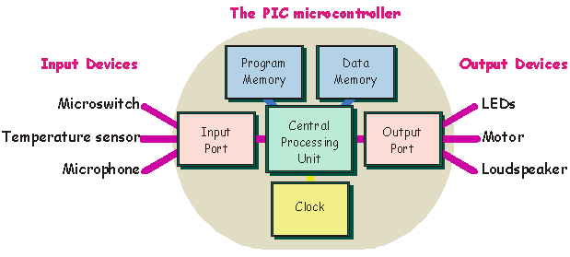

Figure 1 - Microcontroller layout (Fenton, 2019a)

The PIC30F4013 has 48k Program Memory, 2k Data Memory, 5 16-bit timers, 4 input and 4 outputs, 1 SPI, a 13 channel 12-bit ADC (Fenton, 2019a), and 16 16-bit working registers (Microchip Technology Inc., 2005). The chip has five different ports. PORTA is connected to the LCD. PORTBL is connected to the LEDs and buttons, PORTBH to analogue inputs. An SPI component is used to communicate with the (successive approximation) ADC and (string) DAC (Fenton 2019b) connected to PORTF. This runs at a clock speed of 117920000 Hz, subdivided to run internal interrupt timers.

## Tremolo

The input audio is multiplied by an LFO, modulating amplitude. Generally, the LFO is between 0 and 20Hz, sinusoidal or triangular (Pirkle, 2013, p.489). The parameter “Depth” reduces LFO amplitude and offsets it, retaining a peak at maximum amplitude (Pirkle, 2013, p.490).

## Vibrato and Flanger

Vibrato and Flanger differ in the amount of dry signal output. Wet signal is generated by modulating the buffer read position with an LFO. Delay increase creates a pitch decrease and vice-versa; producing a Vibrato effect. Reintroducing the dry signal creates the Flanger effect (Pirkle, 2013, p.328). Delays range from 0 and 10ms (Reiss and McPherson, 2015, p. 52). The depth control reduces the maximum delay.

## Chorus

Chorus blends a dry voice with at least one modulated delay tap. Typical delay values range from a maximum of 20-40ms to a minimum of 7ms (Pirkle, 2013, p. 331). These delays are modulated around a fixed point within this range by a low-pass filtered noise LFO (Fenton, 2019c).

## Wah

Wah mixes a narrow band pass filter, with a variable centre frequency, with its dry input (Zölzer, 2011). Ranges of 400Hz and 1.2kHz give a vocal-like quality (Reiss and McPherson, 2015, p. 106). Most Dunlop Wah pedals range from 300Hz to 2.2kHz (Sweetwater Sound, 2019).

## Bitcrusher

The bitcrusher reduces sample resolution, repeating input samples at a fixed rate (Fenton, 2019e); and bit depth, clearing the lowest bits of a system, reducing amplitude resolution (Strymon, 2018).

## Distortion

Op-amp distortion produces hard-clipping by restricting the maximum and minimum points of the wave to the power rails supplying the op amp. The bias point shifts the centre of the input signal within these power rails, allowing asymmetrical clipping. The signal is boosted by the op-amp and the maximum output of the wave is limited to the power rails. The non-linear characteristics of valves and diodes, can also produce amplitude dependent distortions. (Zölzer, 2011).

# Design and Implementation

An empty, infinite while loop is interrupted to process audio. Five nested timers are set up at different rates, performing different operations within the system.

Pre-calculate variables  
Configure interrupt priorities  
Set interrupt rates

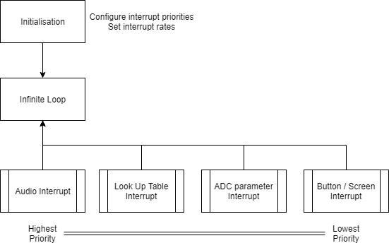

Figure 2 - Program Block Diagram



Figure 3 - Timer Priority and Nesting

## Timers

### TMR1 – Audio Interrupt

A 16-bit unsigned int is read in at a 24kHz sample rate, converted to signed and processed. A switch statement is then used to process the audio sample based on the selected effect. This is reconverted to unsigned and output.

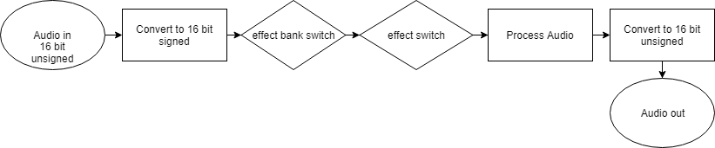

Figure 4 - TMR1 block diagram

### TMR2 – Look Up Table Read-In

The LUT index is incremented at 250Hz. Each LUT contains 250 elements, creating a 1Hz cycle. The sample skip size within the LUT can be changed, increasing frequency up to 16Hz. The noise LUT has its own index counter for the chorus running at 0.25Hz.

### TMR3 –Analogue Digital Conversion

An integer value is read in from the variable resistor at 7 Hz. This value is bitshifted to provide a value between 1 and 16, determining LFO frequency from LUT samples skipped. The Wah effect is bitshifted and given a +300 offset for a satisfactory frequency range (300 - MAXWAH). For bitcrushing, this value determines the sample skip repetition counter. The LCD is updated only on a change in these values.

### TMR4 – Button Reading

Button states are assessed at a 10Hz rate. The LCD is updated if a button is pressed. Norman (2013, p.23) outlines this time requirement for visual feedback.

## Audio Processing

Audio processes are divided into banks of similar effects. The bank ordering (left to right) reflects the layout of effects on a standard pedalboard (Strymon, 2016). The user can cycle through the effects within banks, selecting different effects. Only one effect can be selected at a time and are implemented as follows:

### Tremolo

An interpolated value from the LUT is multiplied (fixed point maths) with the input signal to attenuate it.



Figure 5 - Interpolation of Tremolo LUT, FCV_SINEDATA is the interpolated value.

Depth is implemented using fixed point multiplication. The wet signal is multiplied by Depth directly and the dry signal is calculated by taking away the depth multiplied value from itself. Blending the signals results in a reduced effect intensity.



Figure 6 - Tremolo processing and Wet/Dry mixing

### Vibrato and Flanger

A fractional delay line is used to interpolate audio samples from an LUT set delay point. Depth is controlled by dividing the LUT output by between 10100 and 100, reducing the maximum delay to between 0.125 and 8ms.



Figure 7 - Vibrato processing with audio sample interpolation from a fractional delay line.

### Chorus

Up to four voices are available. Each voice has a predefined sample delay (297, 325, 478, and 503), offset by low passed noise from the noise LUT (between -100 to 79) resulting in 8 to 24ms delays. Linear interpolation is applied, ensuring the LUT value only moves in steps of 1.



Figure 8 - Linear Interpolation of Chorus delay sample offsets



Figure 9 - Loop to calculate sample offset for each delay voice

Voices are summed into a long data type, avoiding overflow, and divided by their number before blending with a wet dry control.



Figure 10 - Chorus voice summing and wet dry mix

### Bitcrusher

An inverted “resolution” value bitshifts the input audio, removing fine resolution, clearing the lowest bits. Resolution ranges from 16-1 representing the bits available in the signal.



Figure 11 - Bit shifting for resolution reduction

Sample rate reduction is applied by repeating the previous sample when a sample counter read from the variable resistor is met.



Figure 12 - Sample rate reduction

### Distortion

A long data type allows the input signal to be boosted without overflow. Before boosting, a bias offset is added. The gain multiplication is calculated in integer maths. The boosted long audio is restricted to the power rail values, a percentage of the full range of an unsigned int.



* Clip to power rails

* Use long type
* Offset Bias
* Boost

Figure 13 - Distortion

### Wah

A state variable filter is implemented for its low frequency stability, and independent Q and centre frequency controls (Chamberlin, 1987) with the following transfer function:

* $Hbp\left(z\right)= \frac{F*\left(1-z^{-1}\right)}{1+\left(F^{2}-q-1\right)z^{-1} +qz^{-2} }$*where q = 1-F*Q*

Figure 14 - State Variable Filter Transfer Function, Fenton (2019d)



Figure 15 - Implemented Wah

Filter coefficients are calculated at initialization and on Q or center frequency changes. The user manipulates Q via the Q damping control (ranging from 1 to 60). Qone (Fig 16) represents Q. The calculation implements according to Fenton (2019d) with some minor changes.

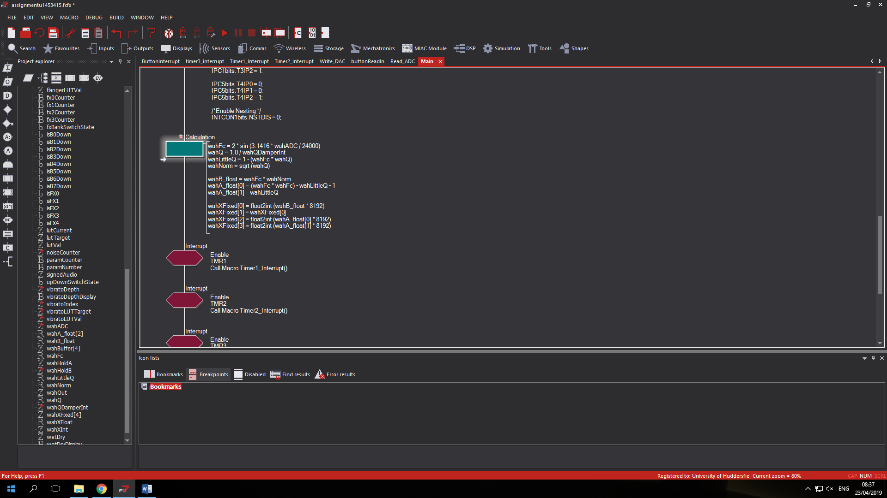

Figure 16 - Implemented Coefficient Calculation

As coefficient b1 is the negative of b0, b1 is not calculated, but set equal to b0 in the fixed point buffer. An MSC calculation (line 15, Fig. 15) substitutes MAC to invert the polarity, removing two expensive float calculations.

## Look Up Tables

One LUT contains an absolute sine wave for Tremolo, Flanger, and Vibrato processing, ranging from 0 to 32767 for fixed point multiplication. This is scaled, representing a sample offset for the Flanger and Vibrato.

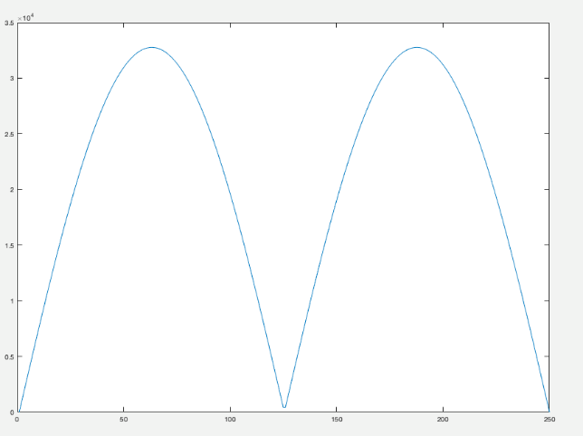

Figure 17 - Absolute Sine Wave LUT

The noise LUT, explained in the chorus section, was generated as follows. 

Figure 18 - Look Up Table Calculation and Filtering



Figure 19 - Low Passed Noise LUT

## User Interface

Buttons B0-B7 and the variable resistor are available to the user. The LCD provides visual feedback of the system state, displaying the selected effect and parameter. Use of the variable resistor overwrites the LCD to displaying its value. B6 and B7 increment or decrement the selected parameter. B5 cycles parameters. B0-B4 select the effect bank. Further consecutive presses cycle effects within the bank. Buttons are debounced for one change per tap. Buttons B0-B4 share a single “button state” (as do B6 and B7) so that only one press at a time within the bank is registered.

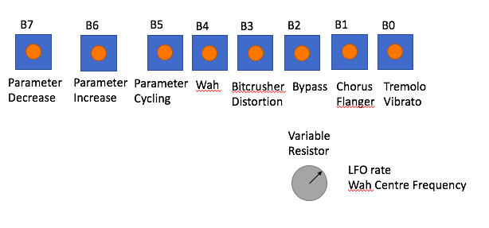

Figure 20 - User Controls

## Switching

Switching effects resets the parameter counter and parameter modulus value (number of parameters) for the parameter cycle button. Different effects have different numbers of parameters, so this modulus ensures valid displays (see FCM_ButtonInterrupt() ).

## Visual Display

Depth and Power are displayed between 0% and 100% and changed in 5% steps. This relates to 1638 steps from a 16380 initialisation value. Some displayed parameters are direct displays of the internal values. Flanger and Vibrato Depths step by 500 from the 5100 initialisation value and are used as LUT value dividers.



Figure 21 – Vibrato and Flanger Depth Ranges and Calculation



Figure 22 - Wet Dry / Depth range

## Fractional Interpolation

LUT values or samples are interpolated between at audio rate. 96 audio interrupts occur between LUT value changes. Thus, FCV_FRACINIT is set to $\frac{1}{96}*2^{15}$ to account to smooth value jumps of the LUT across intermediate audio interrupts (see Fig. 5).

## Program Flow

Initialisation sets chorus offsets, initial wah-filter coefficients, timers, their nesting and priorities, and proceeds to an infinite while loop. TMR4 determines the state of effects by button read in. TMR3 determines relevant parameter states. TMR2 reads in new LUT values. TMR1 processes the audio in relation to the states provided in these parameters.

Results, Further Work, Conclusion, and Discussion

Chorus is the most computationally expensive process due to being written in C. the low points of this wave prove that this processing can be completed within one audio interrupt cycle.

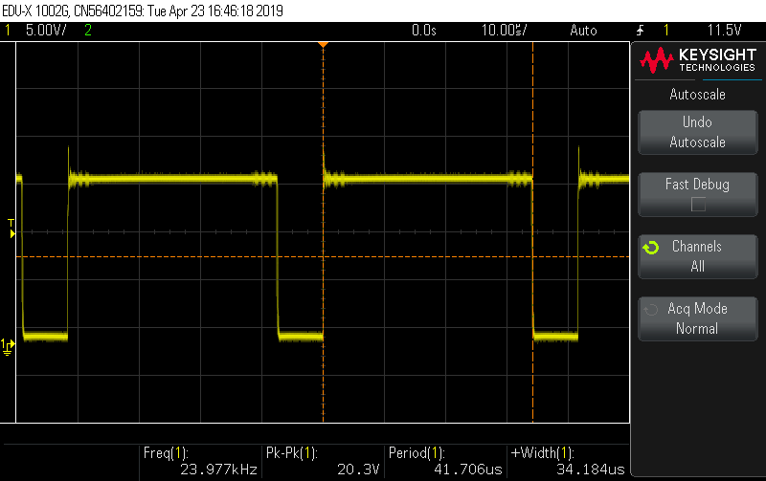

Figure 23 - Throughput of chorus processing

The tremolo is shown by the variable attenuation in the output.

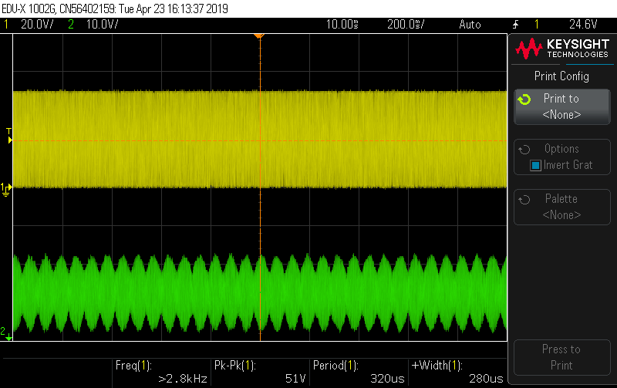

Figure 24 - Tremolo input vs. output

Vibrato is proved functioning due to the variable wavelengths from a tone input.

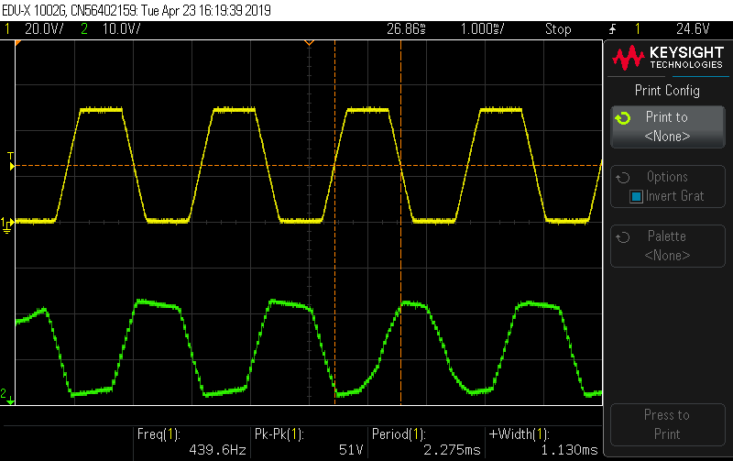

Figure 25 - Vibrato input vs. output

Bitcrusher displays amplitude resolution reduction as follows

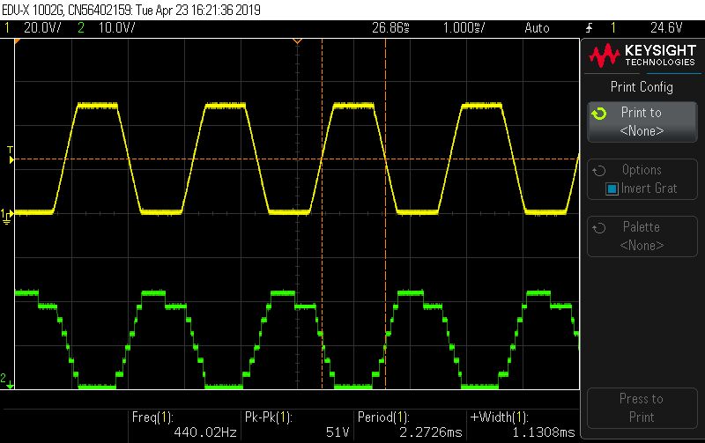

Figure 26 - Bitcrusher resolution reduction

Asymmetrical clipping due to bias points and gain is shown from the distortion

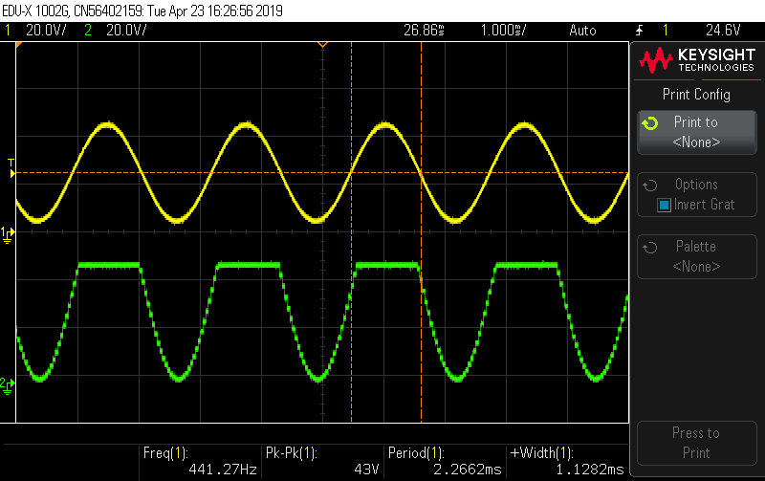

Figure 27 - Distortion input vs. output

The longest delay (24ms) requires 1152 samples at 48kHz, exceeding data memory (2k). Therefore, the system is set at 24kHz, so only 576 samples are required. This allows more time for algorithms to process audio.

The circular buffer could be improved with modulo addressing, allowing faster assembly processing, removing the need for an index point.

An independent wah buffer is unnecessary and could simply utilise the circular buffer. The light dependent resistor on the board could have been used to provide the frequency input for the wah coefficient calculation similar to optical wah pedals. Optical control improves system longevity by removing potentiometer wear (BestWahWah, 2019). Use of y memory for coefficient storage and simultaneous pipelining of audio (in x memory) and coefficients in assembly (Fenton, 2019c) would reduce the number of instruction cycles for wah processing, removing the need for hold variables.



Figure 28 - Pipelining example (Fenton, 2019c)

Implementing soft clipping algorithms and switchable distortion types (overdrive, fuzz, and distortion) stompbox styles outlined in Zölzer (2011) could have improved the distortion effect. The gain control is too course in the lower registers and is linear. A logarithmic curve should be used, similar to gain control pots in audio devices.

The use of effect banks could be expanded to have multiple effect banks selected at once in future implementations.

The Wet/Dry Depth control never achieves full depth. Maximum depth is 32760, not 32767 due to 1638 jumps sizes of the depth parameter.

LED feedback was not implemented due to the limited number of inputs and outputs. This could have been useful to indicate modulation frequency or tempo from LUT high points.

The bitcrusher’s downsampling display is a value meaningless to the user. The effect becomes greater when moved to the right despite a reducing value. This could be better implemented as a sample rate fraction which increases when the variable resistor is turned to the right.

The C code would be better organised with functions (flowcode macros) to remove code repetition and improve readability.

The sine LUT is twice as large as necessary and contains repeated data. A smaller buffer would have saved space in the system.

This assignment has improved my software design skill for specific hardware, restricting variable use and writing algorithms focusing on processing speed rather than accuracy, valuing simplification over perfection in algorithm design, and given me the ability to process samples in real time, rather than buffer processing.

# Glossary of Abbreviations

ADC – Analogue to Digital Converter, converting an analogue input signal (audio samples or control voltage affected by a potentiometer or light dependent resistor) into a digital value.

DAC – Digital to Analogue Converter, converting a digital value into an output voltage.

LFO – Low Frequency Oscillator – a tone below 20Hz, often used to modulate signals.

LUT – Look up Table, an array storing relevant data, perhaps a sine wave or noise. Often used when data is computationally expensive to calculate.

# References and Bibliography

BestWahWah. (2019). *Morley PWO Power Wah Review*. Retrieved from <https://bestwahwah.com/morley-power-wah-review/>.

Chamberlin, H. (1987). Musical Applications of Microprocessors (2nd ed.). Indianapolis, Indiana: Hayden Books.

Fenton, S. (2019a). *Introduction / Flowcode.* [lecture slides]. Retrieved from Brightspace.

Fenton, S. (2019b). *Fixed or Floating?.* [lecture slides]. Retrieved from Brightspace.

Fenton, S. (2019c). *Digital Audio Effects.* [lecture slides]. Retrieved from Brightspace.

Fenton, S. (2019d). *Digital Audio Effects 2.* [lecture slides]. Retrieved from Brightspace.

Fenton, S. (2019e). *dsPIC I/O.* [lecture slides]. Retrieved from Brightspace.

Microchip Technology Inc. (2005). *dsPIC30F/33F Programmer’s Reference Manual*

Norman, D. A. (2013). *The design of everyday things* (Revised and expand ed.). Cambridge, Massachusetts; Cambridge, Mass: MIT Press Ltd.

Pirkle, W. C. (2013). *Designing audio effect plug-ins in C++: With digital audio signal processing theory*. New York: Focal Press. doi:10.4324/9780203573310

Reiss, J. D., & McPherson, A. P. (2015). *Audio effects: Theory, implementation, and application*. New York; London, [England]; Boca Raton, [Florida]: CRC Press.

Strymon. (2016). *Setting up your effect signal chain*. Retrieved from <https://www.strymon.net/setting-up-your-effect-signal-chain/>.

Strymon. (2018). *What is a Bitcrusher?*. Retrieved from <https://www.strymon.net/what-is-a-bitcrusher/>.

Sweetwater Sound. (2019). *Dunlop Wah Comparison Chart*. Retrieved from <https://www.sweetwater.com/feature/dunlop/wah-pedals/index.php>.

Yamaha Guitar Group (2019). Helix. Retrieved from <https://uk.line6.com/helix/>.

Zölzer, U. (2011). *DAFX: Digital audio effects* (2nd ed.). Chichester, West Sussex, England: Wiley. doi:10.1002/9781119991298